**SPRINT – 1**

GROUP-5

**GROCERIES AND MORE...**

**Presented by....**

* Lavanya Anabattula
* Priyanka Sonawane
* Shivani Tandulwar
* Sonal Nikumbhe
* Unnati Kasar
* Srivijaya Namburi

**ETL Sprint 1 Project Case Study ‘Grocery & More’**

**Problem Statement**

An online grocery chain 'Grocery & More' has multiple stores in different cities in India. Customers can either buy directly from the store or order their products online. 'Grocery & More' procures the products from different vendors. 'Grocery & More' wants to analyze their profit & margins for each store from data available for the last 3 years. They also want to analyze customer buying trends. To get that insight, 'Grocery & More' wants to create a Data Warehouse solution on which they can do data analytics.

**ENTITY RELATIONSHIP DIAGRAM**

The ER model defines the conceptual view of a database. It works around real-world entities and the associations among them.

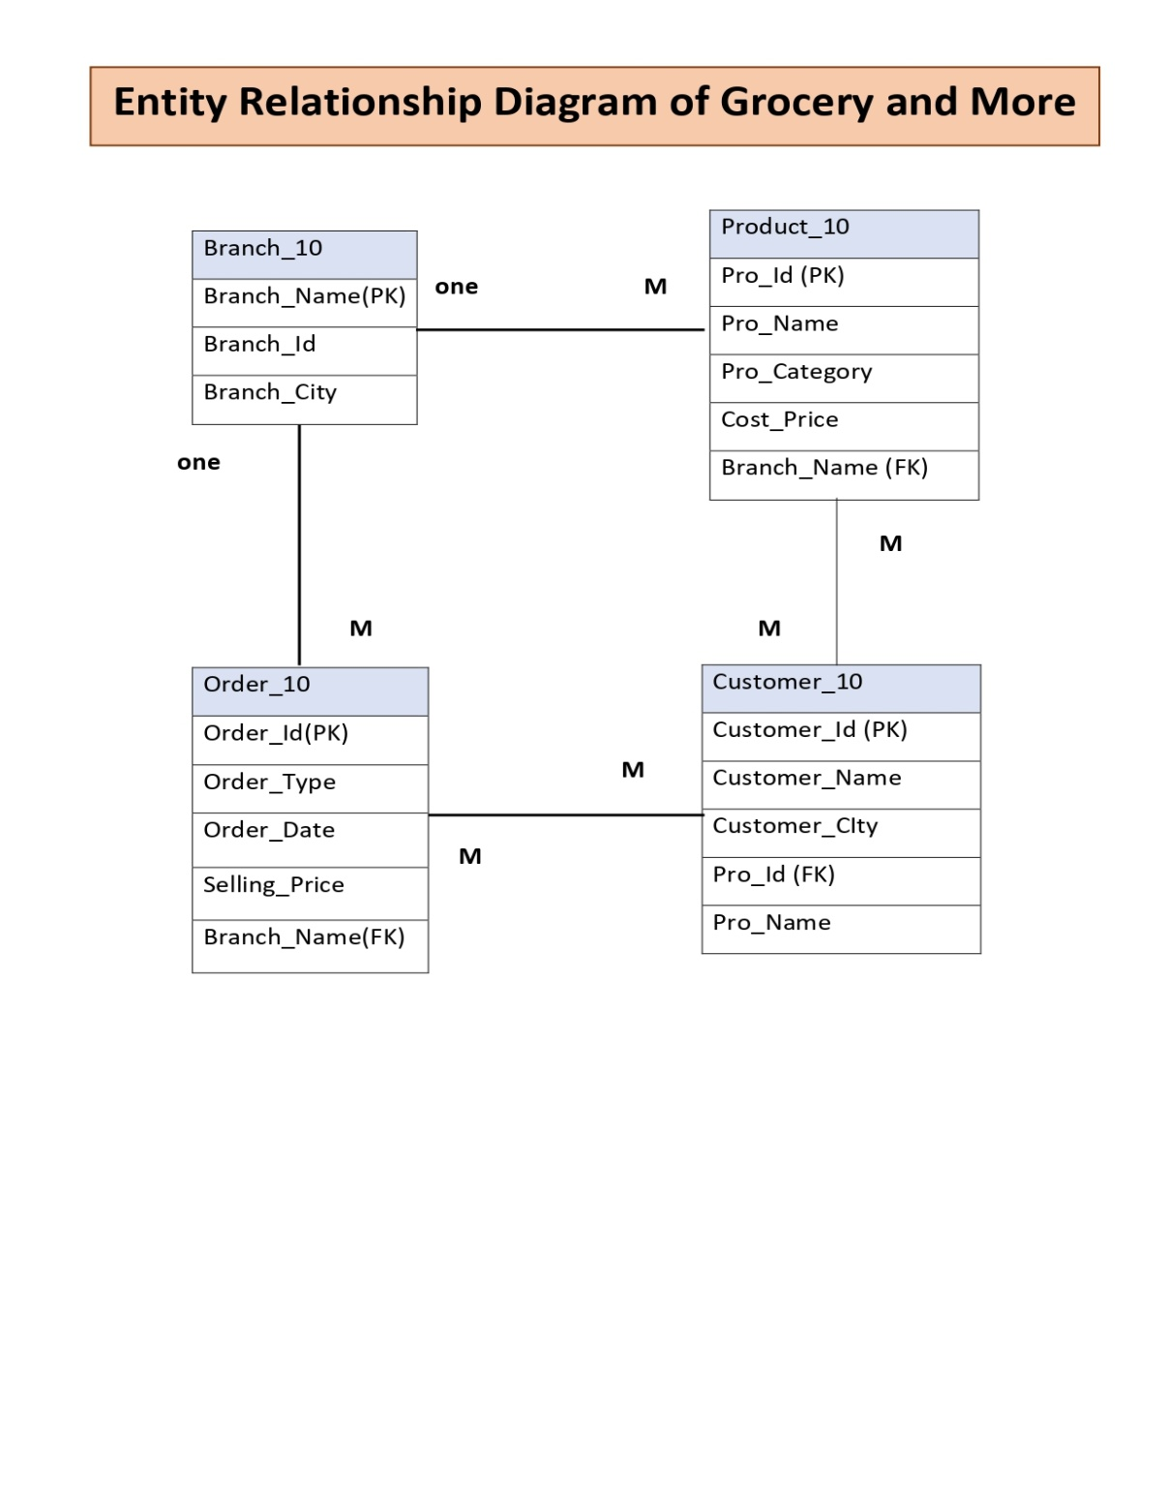

* **SOURCE TABLES**

BRANCH_10:

Query:

* CREATE TABLE BRANCH_10 (BRACH_NAME VARCHAR2(15) PRIMARY KEY, BRACH_ID NUMBER,BRANCH_CITY VARCHAR2(15));

DESCRIPTION:

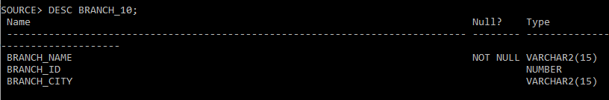

**PRODUCT TABLE:**

QUERY:

* CREATE TABLE PRODUCT_10(PRO_ID NUMBER PRIMARY KEY ,PRO_NAME VARCHAR2(15),PRO_CATEGORY VARCHAR2(15),COST_PRICE NUMBER BRANCH_NAME REFRENCES BRANCH_10 (BRANCH_NAME));

DESCRIPTION:

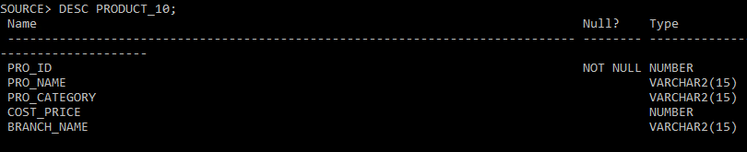

**ORDER TABLE:**

QUERY:

* CREATE TABLE ORDER_10 (ORDER_ID NUMBER,ORDER_TYPE VARCHAR2(10),ORDER_DATE DATE,SELLING_PRICE NUMBER,BRANCH_NAME REFRENCES BRACH_10(BRANCH_NAME));

DESCRIPTION:

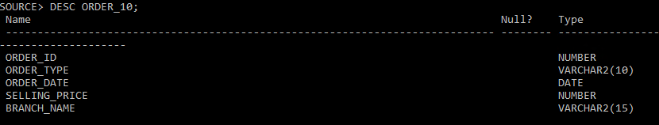

**CUSTOMER TABLE:**

QUERY:

* CREATE TABLE CUSTOMER _10(CUSTOMER_ID NUMBER PRIMARY KEY,CUSTOMER_NAME VARCHAR2(10),CUSTOMER_CITY VARCHAR2(10),PRODUCT_ID REFRENCES PRODUCT_10(PRO_ID),PRO_NAME VARCHAR2(10));

DESCRIPTION:

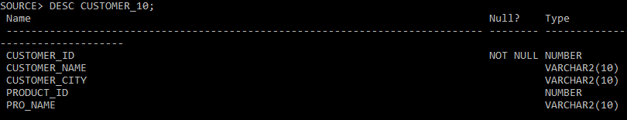

* **TARGET TABLES:**

**1.TRG_PROFIT_MARGIN_SP1:**

QUERY:

* CREATE TABLE TRG_PROFIT_MARGIN_SP1(BRANCH_NAME VARCHAR2(10),SELLING_PRICE NUMBER,COST_PRICE NUMBER, PROFIT_MARGIN NUMBER);

DESCRIPTION:

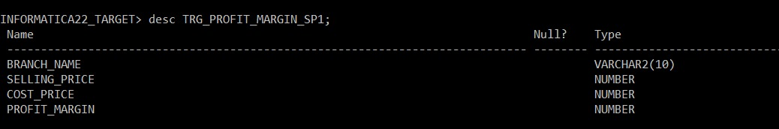

**2.TRG_BUYING_TRENDS_SP1:**

QUERY:

* CREATE TABLE TRG_BUYING_TRENDS_SP1(PRODUCT NAME VARCHAR2(10),BUYING_TRENDS NUMBER, RANK NUMBER);

DESCRIPTION:

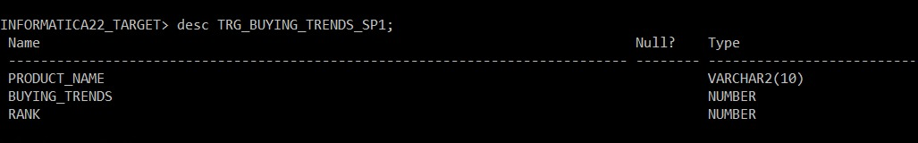

**MAPPINGS**

**MAPPING 1:**

M_MAP_PROFIT_MARGIN_SP1:

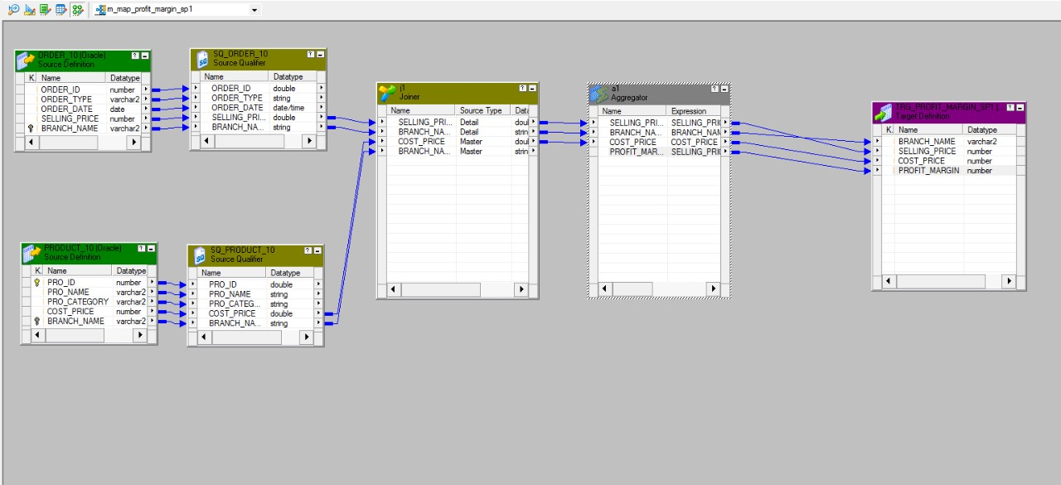

M_MAP_BUYING_TRENDS_SP1:

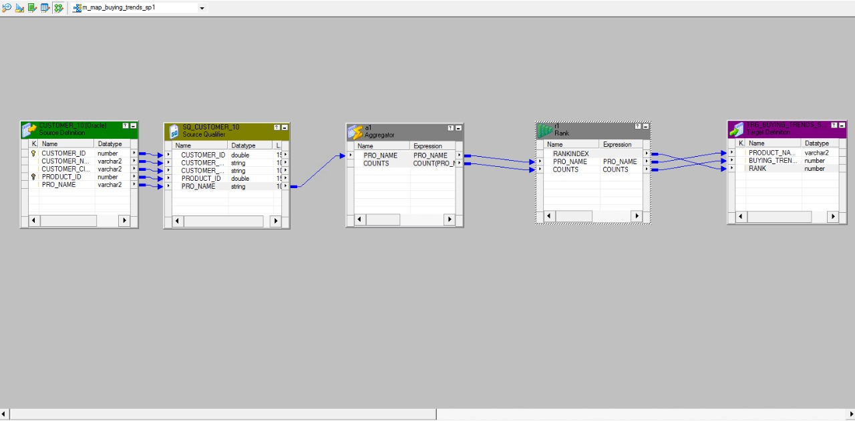

**TEST CASES**

**UNIT TESTING:**

Unit testing involves the testing of each unit or an individual component of the software application. It is the first level of functional testing. The aim behind unit testing is to validate unit components with its performance.

**#1) Test Case ID: T1**

**Test Case Purpose:**Validate workflow – WF_S_M_MAPP_EATING_PREFF

**Test Procedure:**

* Go to workflow manager
* Open workflow
* Workflows menu-> click on validate

**Input Value/Test Data:**Sources and targets are available and connected  
Sources:CUSTOMER_6  
Mappings: M_MAPP_EATING_PREFF  
Targets: EATING_PREFERENCES  
Session: S_M_MAPP_EATING_PREFERENCES

Transformations:

1.Aggregator: COUNT aggregator is used to group and count Eating preference of Customers

2.Rank- RANK Transformation is used to rank eating preferences of rows.

**Expected Results:**Message in workflow manager status bar: “Workflow WF_S_M_MAPP_EATING_PREFF is valid “

**Actual Results:**Message in workflow manager status bar: “Workflow WF_S_M_MAPP_EATING_PREFF is valid “

**Remarks: Pass**

**Tester Comments:**

Retrieved the data from source table CUSTOMER_6 and grouped it in 3 category Vegan ,Vegetarian, Non-Vegetarian using transformations. The output is useful to identify the eating preference of customers.

**#2) Test Case ID: T2**

**Test Case Purpose:**Validate workflow – WF_S_M_PURCHASE_PREFF

**Test Procedure:**

* Go to workflow manager
* Open workflow
* Workflows menu-> click on validate

**Input Value/Test Data:**Sources and targets are available and connected  
Sources: TOUR_6  
Mappings: M_MAPP_PURCHASE_PREFF  
Targets: PURCHASE  
Session: S_M_MAPP_PURCHASE_PREFF

Transformations:

1.Aggregator: COUNT aggregator is used to group and count Eating preference of Customers

2.Rank: RANK Transformation is used to rank eating preferences of rows.

**Expected Results:**Message in workflow manager status bar: “Workflow WF_S_M_MAPP_PURCHASE_PREFF is valid “

**Actual Results:**Message in workflow manager status bar: “Workflow WF_S_M_MAPP_PURCHASE_PREFF is valid “

**Remarks: Pass**

**Tester Comments:**

Retrieved the data from source table TOUR_6 and grouped it in 3 category Domestic, International, Localising transformations. The output i.e target table PURCHASE is useful to identify the purchase preference of customers.

**#3) Test Case ID: T3**

**Test Case Purpose:**Validate workflow – WF_S_M_MAPP_VISITOR_TIME_TYPE

**Test Procedure:**

* Go to workflow manager
* Open workflow
* Workflows menu-> click on validate

**Input Value/Test Data:**Sources and targets are available and connected

Sources: VISITOR_6  
Mappings: M_MAPP_VISITOR_TIME_TYPE  
Targets: VISITOR_TYPE , DATE_TIME.   
Session: S_M_MAPP_VISITOR_TIME_TYPE

Transformation:

* For target table – VISITOR_TYPE

1.Aggregator: To count Visitors type

2.Rank : To Rank the rows according to count of visitors type.

* For target table – DATE_TIME

1.Expression : To convert data type of DATETIME column from DATE/TIME to String.

2.Aggregator : To COUNT the peak hours of most visitors visit

3.Rank : Ranking the date time on basis of peak hours.

**Expected Results:**Message in workflow manager status bar: “Workflow WF_S_M_MAPP_VISITOR_TIME_TYPE is valid “

**Actual Results:**Message in workflow manager status bar: “Workflow WF_S_M_MAPP_VISITOR_TIME_TYPE is valid “

**Remarks: Pass**

**Tester Comments:**

Retrieved the data from source table VISITOR_6 in order to know the most crowded visiting hours and the type of visitors whether it is LOCAL or TOURIST various using transformations. The output i.e target table VISITOR_TYPE and DATE_TIME are useful to identify the peak hours and type of visitors of destination.

**INTEGRATION TESTING:**

Integration testing is the second level of the software testing process comes after unit testing. In this testing, units or individual components of the software are tested in a group. The focus of the integration testing level is to expose defects at the time of interaction between integrated components or units.

**Mappings are:-**

1. m_map_profit_margin_sp1
2. m_map_buying_trends_sp1

**Test Case ID: T1**

**Test Case Purpose**: Validate Mapping,m_map_profit_margin_sp1, Validate Workflow, wf_m_map_profit_margin_sp1

**Test Procedure:**

* + - * Go to Mapping
      * Connect Source and Target
      * Use Transformation
      * Connect All and then Save it
      * Go to menu> mapping> Click on validate

**Input Value/Test Data:**

Sources: ORDER_10, PRODUCT_10

Target**:** TRG_PROFIT_MARGIN_SP1

**Transformation:**

1. Joiner **–** joint condition is used to join fields between the two sources.
2. Aggregator- Aggregator is used to group and calculate profit & margin of products based on branch name.

**Expected Result:**

1. Check Mapping =>Mapping is validate
2. Go to workflow =>Message in workflow manager status bar: “Workflow wf_s_m_map_profit_margin_sp1 is valid”

**Actual Result:** Message in workflow manager status bar: ”Workflow wf_s_map_profit_margin_sp1 is valid”

**Remarks** : **Pass**

**Tester comments:**

The data from source tables i.e. ORDER_10 and PROFIT_10 are joined together to calculate the profit. This is used to calculate accurate profit each Branch wise.

**Test Case ID: T2**

**Test Case Purpose**: Validate Mapping m_map_buying_trends_sp1, Validate Workflow

wf_s_ m_map_buying_trends_sp1

**Test Procedure:**

* + - * Go to Mapping
      * Connect Source and Target
      * Use Transformation
      * Connect All and then Save it
      * Go to menu> mapping> Click on validate

**Input Value/Test Data:** Connect Sources and Target tables

Source Table**:** CUSTOMER_10

Target Table: TRG_BUYING_TRENDS_SP1

**Transformation:**

**Aggregator:** COUNT Aggregator is used to group and count product name

**Rank:** RANK is used to rank Buying products.

**Expected Result:**

1. Check Mapping=> Mapping is validate
2. Go to workflow > Message in workflow manager status bar: “Workflow

wf_s_ m_map_buying_trends_sp1 is valid”

**Actual Result:** Message in workflow manager status bar : ”Workflow

wf_s_ m_map_buying_trends_sp1is valid”

**Remarks** : **Pass**

**Tester comments:**

The data is retrieved from CUSTOMER_10 in order to count the most purchased product and rank it. This table is useful to know the current buying trends. The output will be show in sql.

**REGRESSION TESTING:**

Regression testing is a type of software testing. Test cases are re-executed to check the previous functionality of the application is working fine, and the new changes have not produced any bugs.

**Mappings are:-**

1. m_map_profit_margin_sp1

2. m_map_buying_trends_sp1

**#1).Test Case ID: T1**

**Test Case Purpose**: Validate Mapping m_map_profit_margin_sp1, Validate Workflow, wf_m_map_profit_margin_sp1

**Test Procedure**:

* Go to Mappings
* Select option debugger
* Start debugger >Next>Use an existing session instances>Next>Select session>Next>Target table option>finish.
* Next in instances.

**Input Value/Test Data**:

Sources: ORDER_10, PRODUCT_10

Target : TRG_PROFIT_MARGIN_SP1

**Transformation**: 1. Joiner – A join condition is used to join fields between the two sources. 2. Aggregator - Aggregator is used to group and calculate profit & margin of products based on branch name.

**Expected Result**: 1. Check Mapping => Mapping is validate 2. Go to workflow => Message in workflow manager status bar: “Workflow wf_s_m_map_profit_margin_sp1 is valid”

**Actual Result**: Message in workflow manager status bar:”Workflow wf_ s_map_profit_margin_sp1 is valid”

**Remarks: Pass**

**Tester comments**: The data is retrieved from two source tables i.e. ORDER_10 and PRODUCT_10 are joined together to calculate the profit. It is useful to give accurate profit according to each Branch wise.

**#2).Test Case ID: T2**

**Test Case Purpose**: Validate Mapping m_map_buying_trends_sp1, Validate Workflow wf_s_ m_map_buying_trends_sp1

**Test Procedure:**

* Go to Mappings
* Select option debugger
* Start debugger• >Next>Use an existing session instances>Next>Select session>Next>Target table option>finish.
* Next instances.

**Input Value/Test Data**: Connect Sources and Target tables

Source Table : CUSTOMER_10

Target Table : TRG_BUYING_TRENDS_SP1

**Transformation:**

1.Aggregator: COUNT Aggregator is used to group and count Product name

2.Rank: RANK Transformation is used to rank Buying Products according to customer preference.

**Aggregator**: COUNT Aggregator is used to group and count product name

**Rank**: RANK is used to rank Buying products.

**Expected Result:**

1. Check Mapping=> Mapping is validate

2. Go to workflow > Message in workflow manager status bar: “Workflow Wf_s_ m_map_buying_trends_sp1 is valid”

**Actual Result**: Message in workflow manager status bar : ”Workflow Wf_s_ m_map_buying_trends_sp1 is valid”

**Remarks**: **Pass**

**Tester comments:**

The data is retrieved from CUSTOMER_10 in order to count the most purchased product and rank it. This table is useful to know the current buying trends and also give rank according to product

**OUTPUT:**

QUERY:

* SELECT * FROM TRG_PROFIT_MARGIN_SP1;

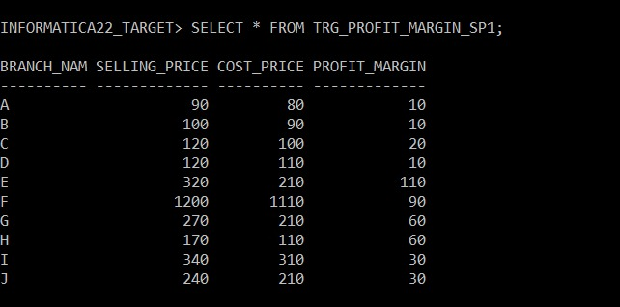

* SELECT * FROM TRG_BUYING_TRENDS_SP1;

